Task №1. The computer types. Computer devices. Input and output devices.

- Write the computer devices
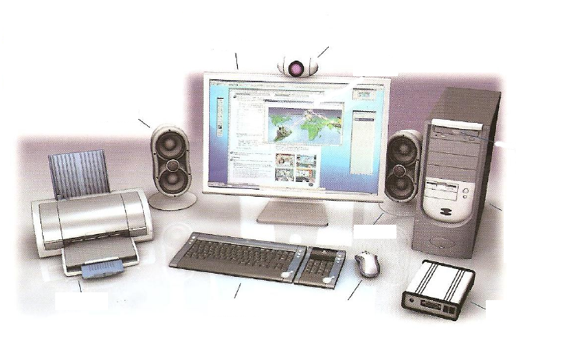

- Matching

Types of Computer | Properties
1. Computers | а) portable computer (easy to handle and transport)
2. Ultrabook | b) portable mobile device
3. Desktop computer | c) ultra-thin, lightweight laptop
4. Tablet | d) mobile phone with many functions of computer
5. Notebook or Laptop | e) are electronic machines that make mathematical and logical calculations.
6. Smartphone | f) a device that has separate parts (system unit, monitor, keyboard, mouse)

- Plase write output and input devices
OUTPUT –
____________________________________________________________________________________________________________________________________________________________________________________________
INPUT –
____________________________________________________________________________________________________________________________________________________________________________________________
PROCESSING
______________________________________________________________________________________________
STORAGE
______________________________________________________________________________________________

- Write the measurement units information in descending order.
_______________________________________________
_______________________________________________
_______________________________________________
_______________________________________
_______________________________________________

