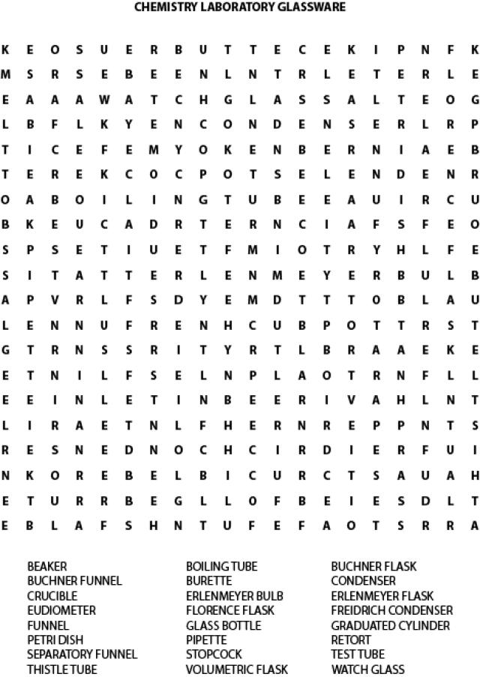

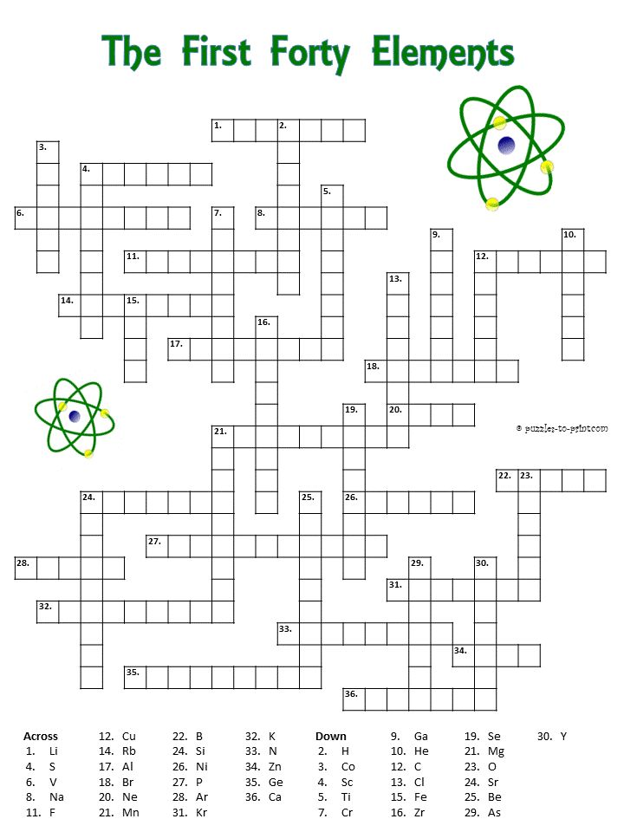

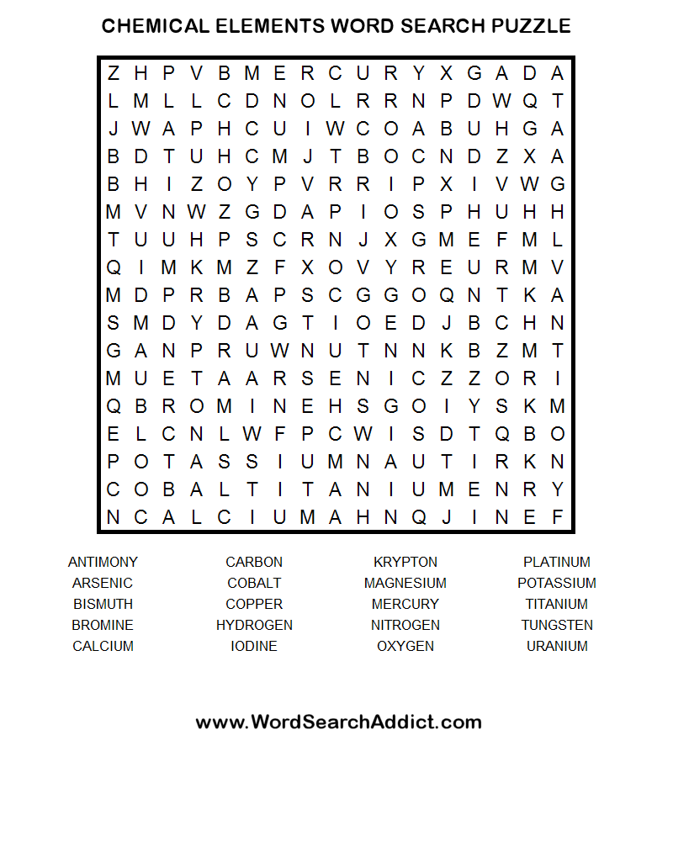

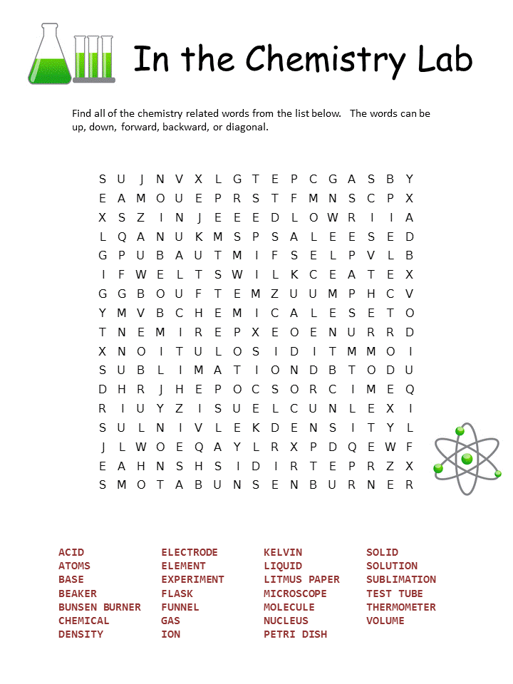
Тест
What is the systematic name of the following compound?
CaF₂
vvv Calcium fluoride
Calcium fluorine
Carbon fluorine
Carbon fluoride
What is the systematic name of the following compound?
Na₂O
DIsodium(I) oxide
Sodium(I) oxide
Disodium oxide
vvvv Sodium oxide
What is the systematic name of the following compound?
SnO₂
Tin(II) oxide
VVVV Tin(IV) oxide
Selenium(IV) oxide
Selenium(II) oxide
What is the systematic name of the following compound?
{KBr
Krypton(I) bromide
Potassium(I) bromide
cccc Potassium bromide
Krypton bromide
What is the formula of iron(III) oxide?
Fe​2​​O
FeO
​​ Fe​3​​O​2​​
Fe​2​​O​3​​
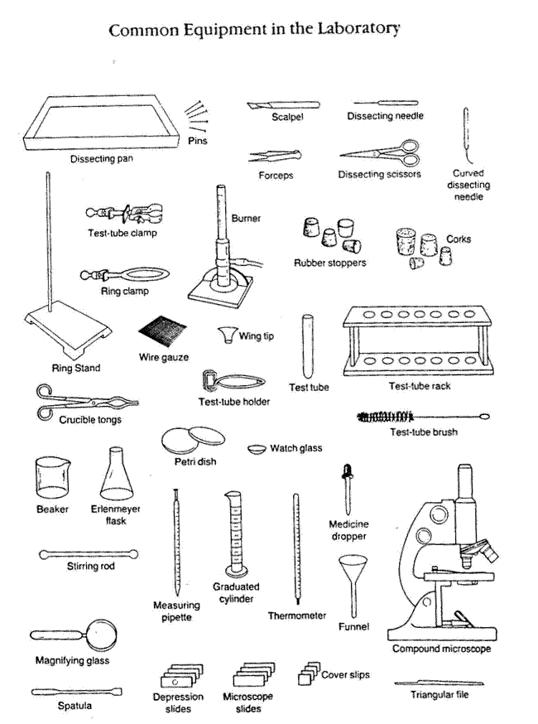

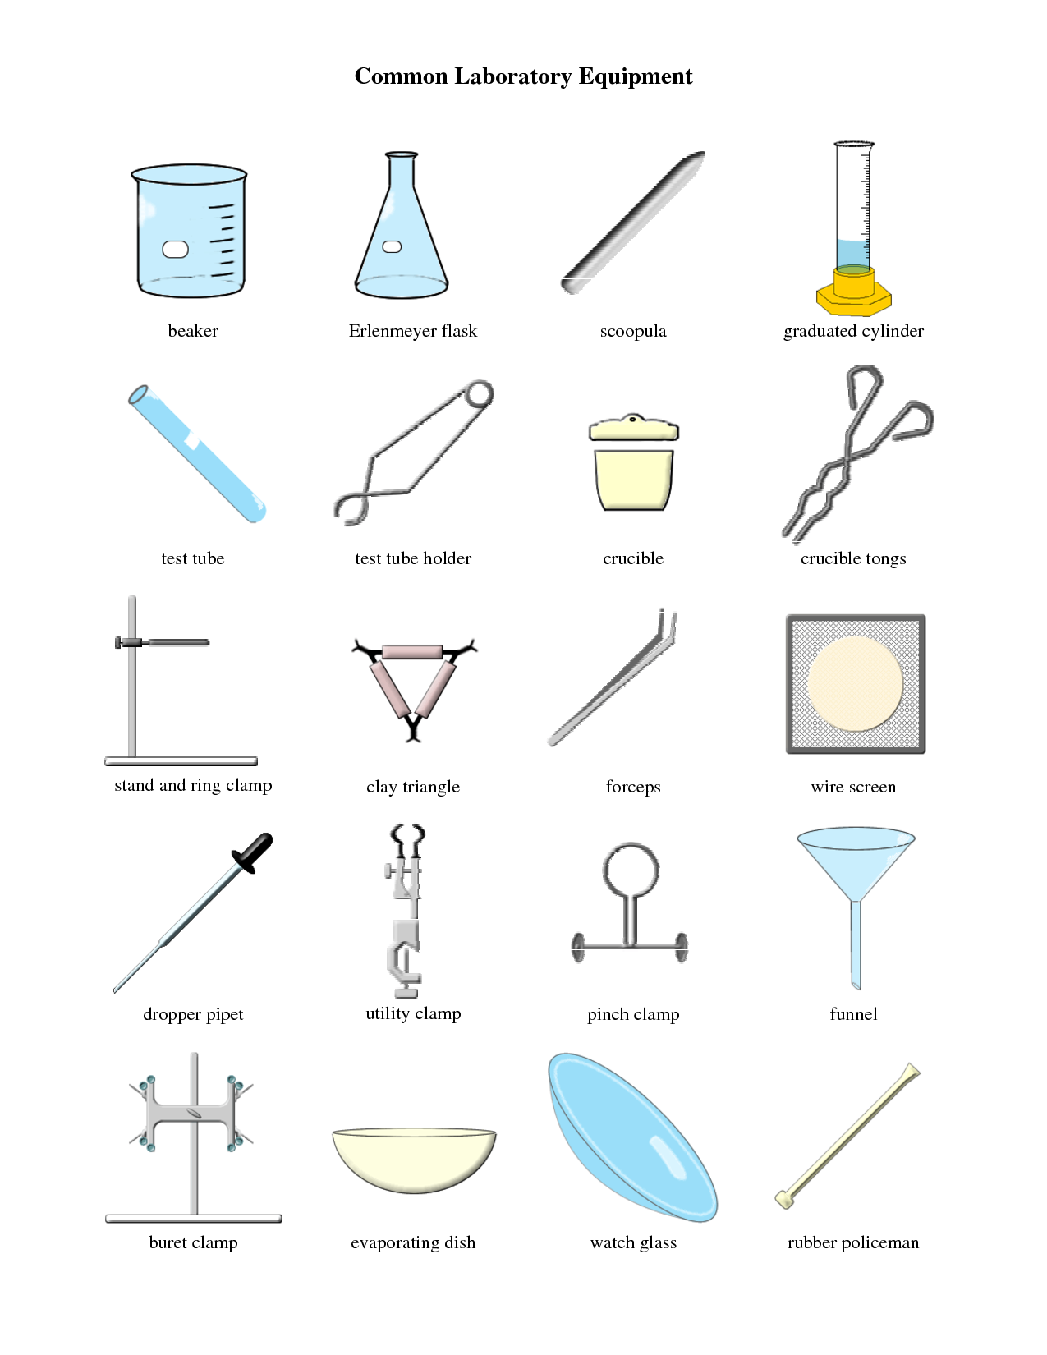

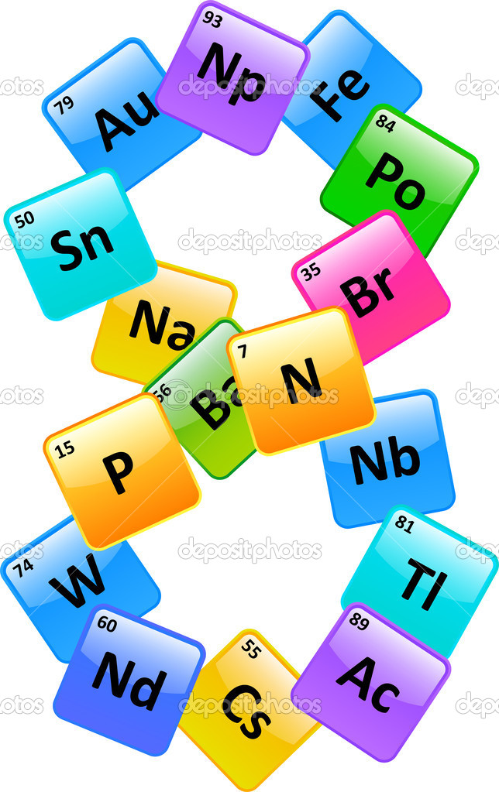
VOCABULARY WORK
Naming: атау / название
Ion: ион
Important: маңызды / важный
Given: берілген / дано
Metal: метал/ металл
Nonmetal: бейметал / неметалл
Contain: құрамында бар / содержит
Type: түрі / вид
Combination: қосылу / соединение (в реакции)
Compound: қосылыс / соединение
Always: әрқашан / всегда
First: бірінші / первый
Exercise: жаттығу / упражнение
Variable: айнымалы / переменная
Valency: валенттілік / валентность
Symbol: символ
Indicate: анықтау / определить
Parentheses: жақшалар / скобки
Number: нөмір / номер
Other: басқа / другой
Greek: грекше / греческий
Need : керек / нужен

VOCABULARY WORK
Concept: концепция
Important: маңызды / важный
Accept: қабылдау / принять
Particle: бөлшек / частица
Pencil: қарындаш / карандаш
Large: кең, үлкен / широкий, большой
Huge: орасан үлкен / огромный
Easy/Easier: жеңіл, оңай / легко
Quantity: саны / количество
Weighs (v): ... салмақта / весит
Conversion: конверсия
Factor: фактор
Calculation: есептеу / рассчитать
Remember: есте сақтау / помнить
Mass: масса
Volume: көлем / объем
Temperature: температура
Pressure: қысым / давление
Standard: стандартты / стандартный
Various: әр түрлі / различный
Substance: зат / вещество
Following: келесі / следующий
Between: арасында / между
Formula: формула
If: егер / если
Most important: ең маңызды / самый важный
Known as: деп аталады / известен как
Abbreviated as: деп қысқартылған / сокращено как
Can be used: қолданылады / может быть использовано
Is defined: анықталған / определено
Is called: аталады / называется
Is related: қатысты / относится
The help of: көмегімен / с помощью

Reactions
1. 2 moles of oxygen reacted with 2 moles of sulfur. Find mass of produced compound.
2. Find mass of produced water if 8 g of oxygen reacted with excess amount of hydrogen.
3. 28 g of carbon monoxide reacted with excess amount of oxygen. What is the volume of produced gas at STP?
4. 200 g of calcium carbonate decomposed into calcium oxide and carbon dioxide. Find mass of produced gas.
5. 10 moles of sodium reacted with 10 moles of chlorine. What is the mass of produced compound?
6. 108 g of aluminum reacted with excess amount of hydrochloric acid. Find volume of produced gas at STP.
7. According to the following reaction:
Na + Cl2 à NaCl
What is the mass of sodium if 58,5g of salt was produced?
8. According to the following reaction:
BaCl2 + K2SO4 = BaSO4 + KCl
How many grams of potassium sulfate is needed, if 52 g of barium chloride is fully reacted?
9. According to the following reaction:
CuCl2 + Fe = FeCl2 + Cu
How many grams of iron is necessary to totally react with 27 g of copper chloride?
10. 34,25 g of barium reacted with 49 g of sulfuric acid. Find volume of the produced gas at STP.

