Tasks in Informatics

- Write the computer devices
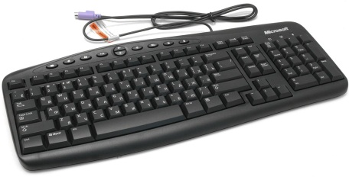
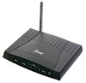
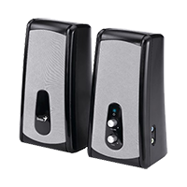
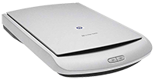
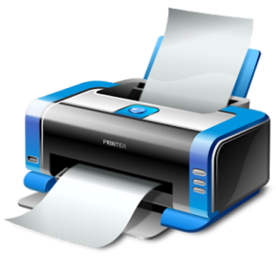
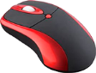
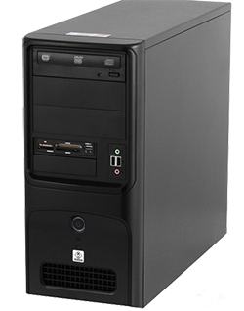
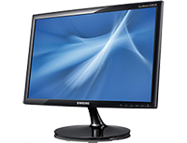

Computer devices:
monitor  keyboard  mouse  printer  motherboard  microphone | modem  speaker  webcam  system unit  сentral Processing Unit (CPU or Processor)  scanner

- Matching types of computer between definition

Types of Computer | Answer | Definition
- Ultrabook  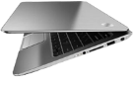 |  | b) portable mobile device
- Desktop computer  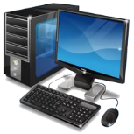 |  | c) ultra-thin, lightweight laptop
- Tablet  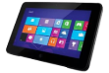 |  | d) mobile phone with many functions of computer
- Notebook  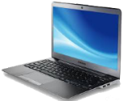 |  | а) portable computer (easy to handle and transport)
5. Smartphone  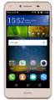 |  | e) a device that has separate parts (system unit, monitor, keyboard, mouse)

- Write the missing word
____________ are electronic machines that make mathematical and logical calculations.
Mouse’s function is to ________ the cursor around the monitor.
A file consists of a ______ and an extension.
The ___________is an input device information in computer.

- Match the words to compare computers and humans.
Computer |  |  |  | Human
CPU | 1  1 |  | 1 | Eye
Speaker | 1  2 |  | 1 | Ear
Microphone | 1  3 |  | 1 | Brain
Webcam | 1  4 |  | 1  2 | Mouth
System unit | 1  5 |  | 1 | Clothes

- Matching tools between name of the tool
 | Tool |  | Name of the tool
1 |  |  | - background color
2 |  |  | - thickness
3 |  |  | - primary color
4 |  |  | - insert
5 |  |  | - skew
6 |  |  | - resize
7 |  |  | - changing colors
8 |  |  | - copy
9 |  |  | - allotment tool
10 |  |  | - crop picture
11 |  |  | - cut

